COMMUNICATION THEORY

LAB ASSIGNMENT 2

Names of students:

Mohamed Abdelwahab 43-16928

Abdelrahman Gelany 43-17100

Tutorial: T-03

Supervised by:

ENG.Nada Ayman

December 2019

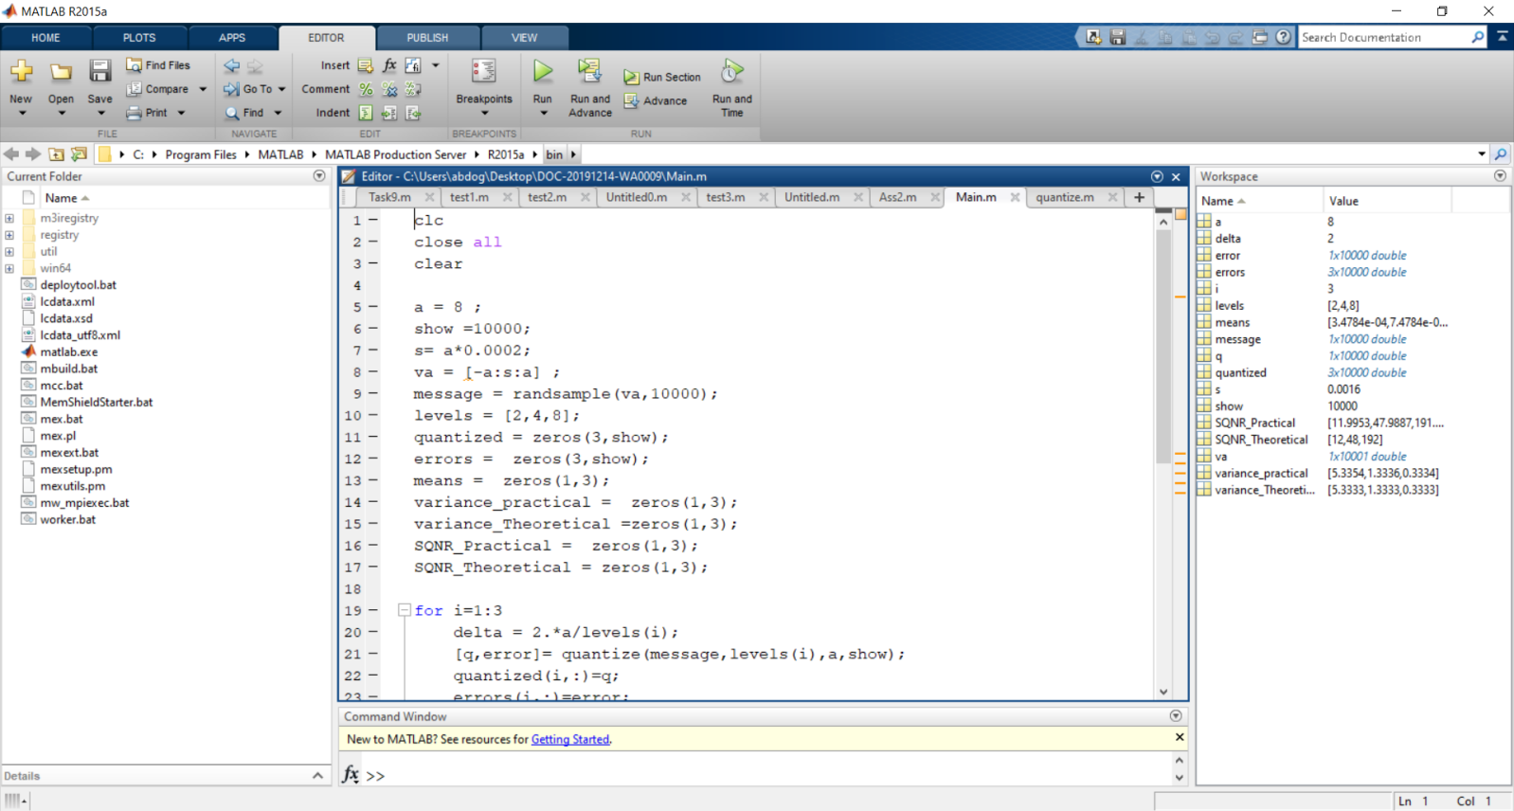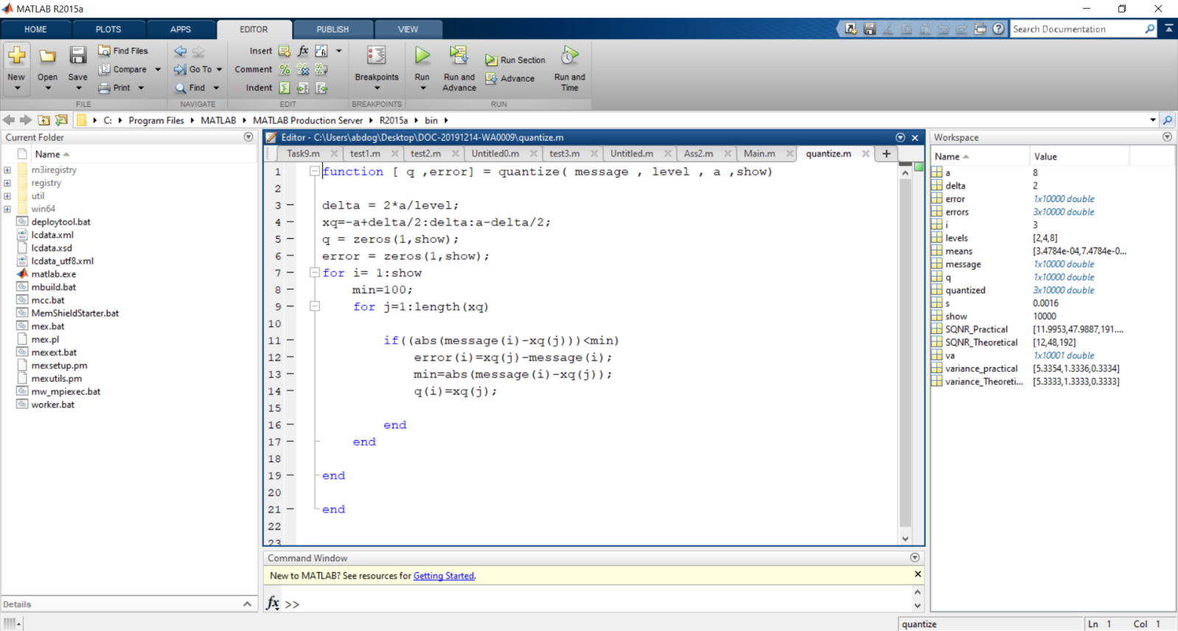

MATLAB CODE

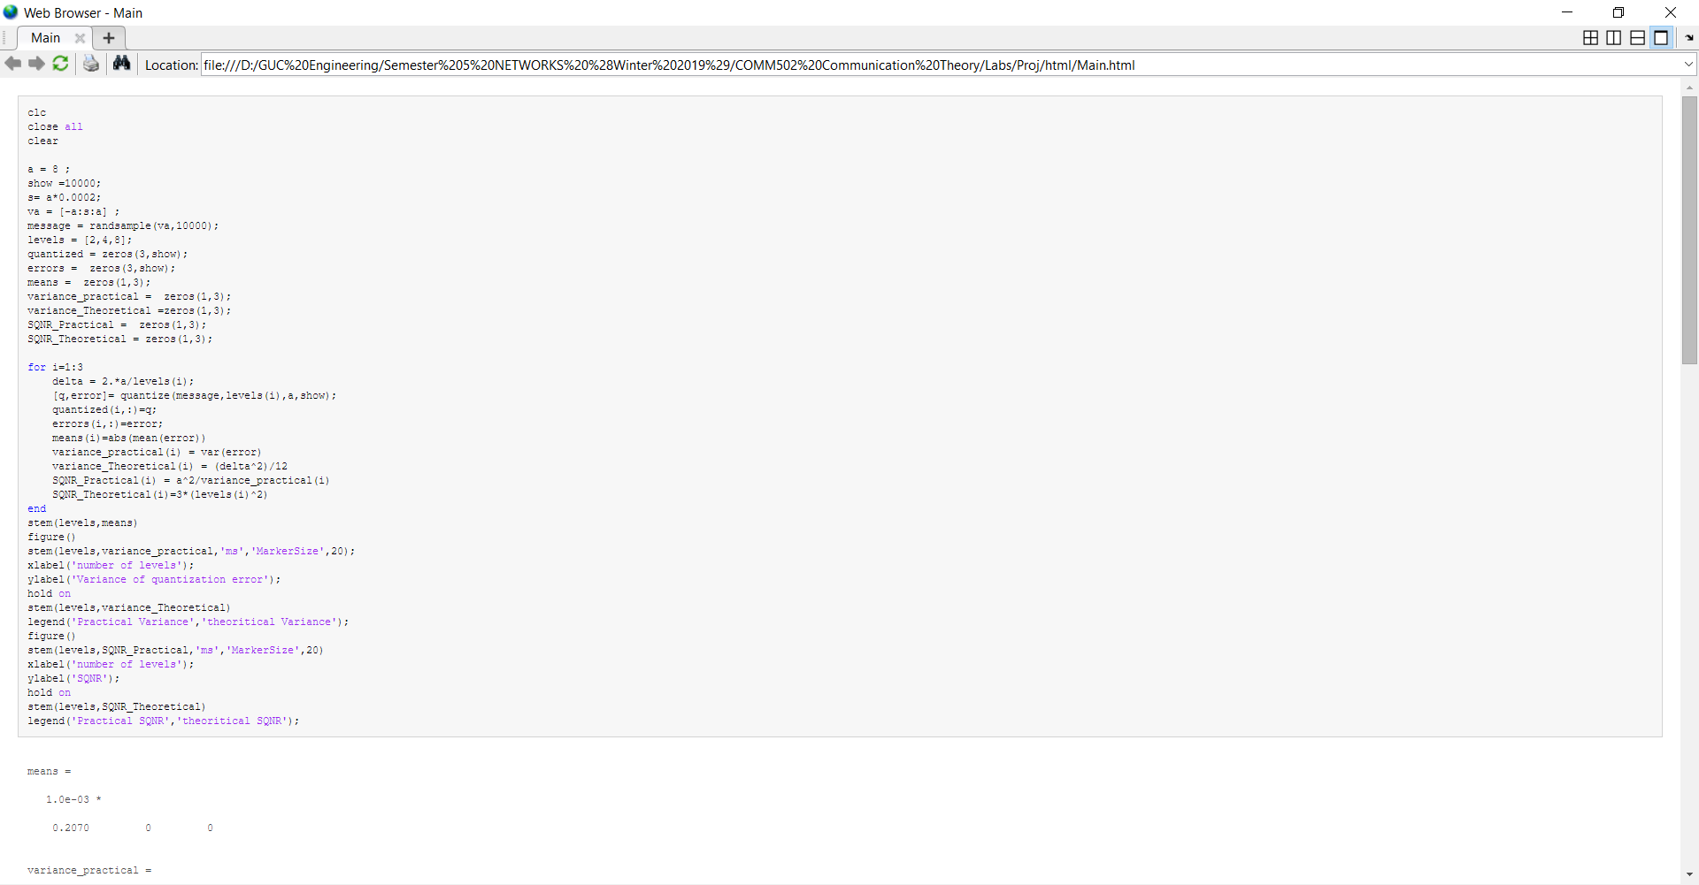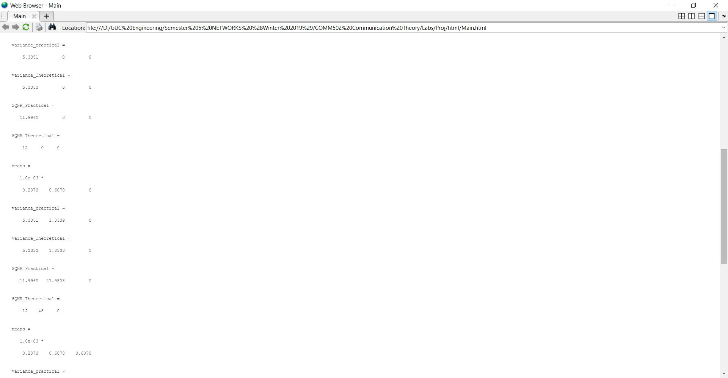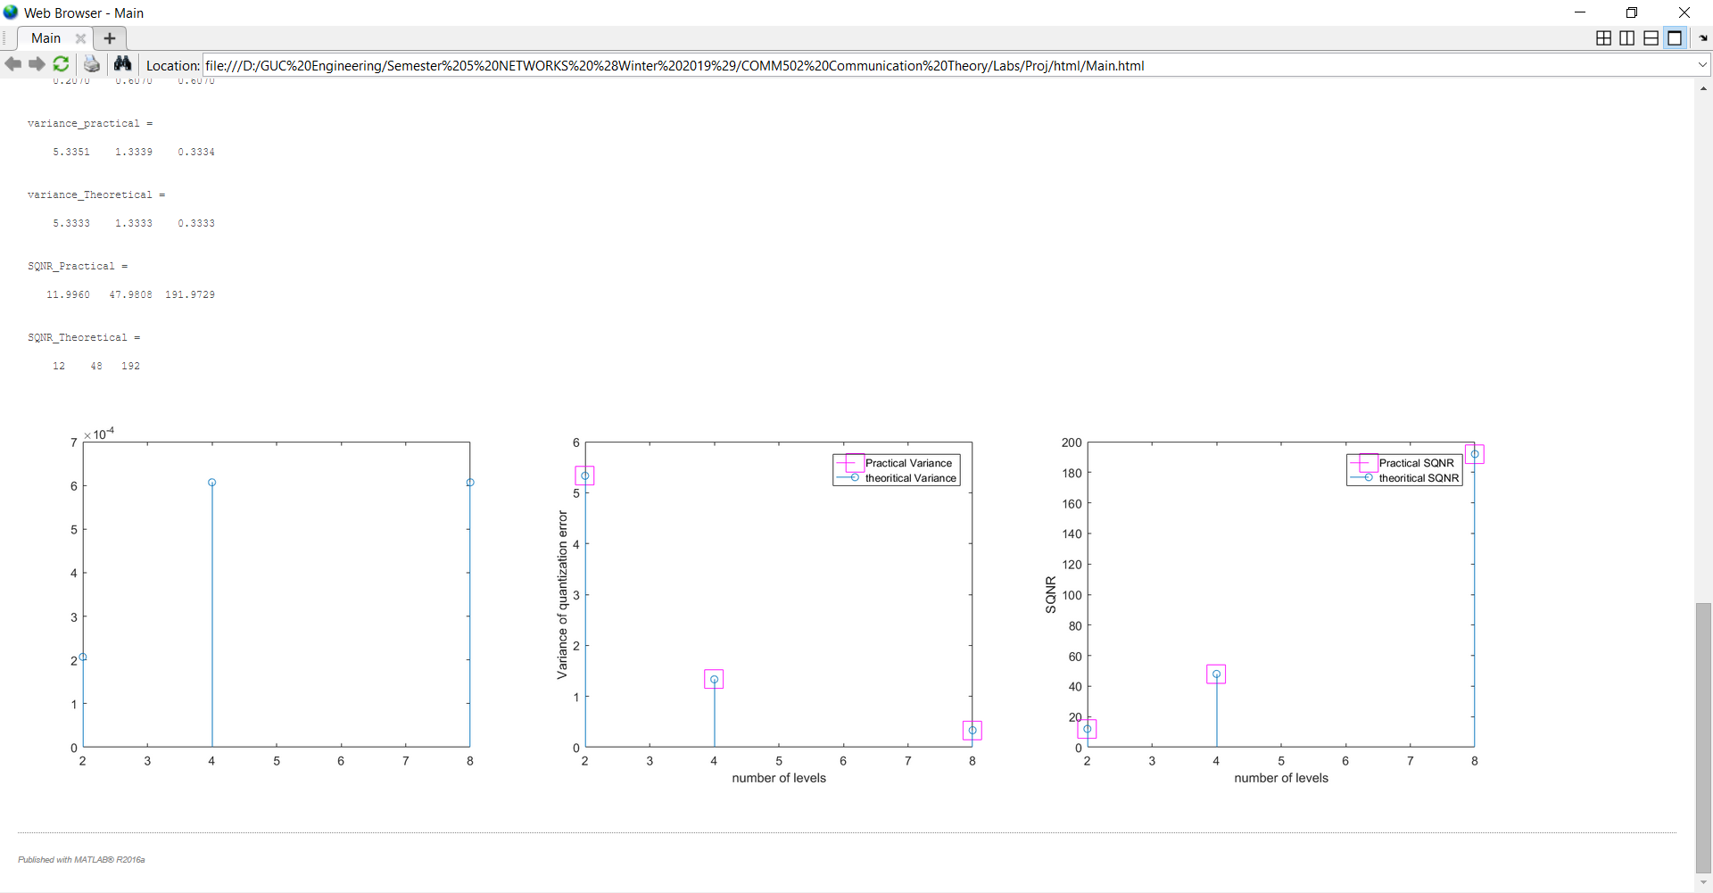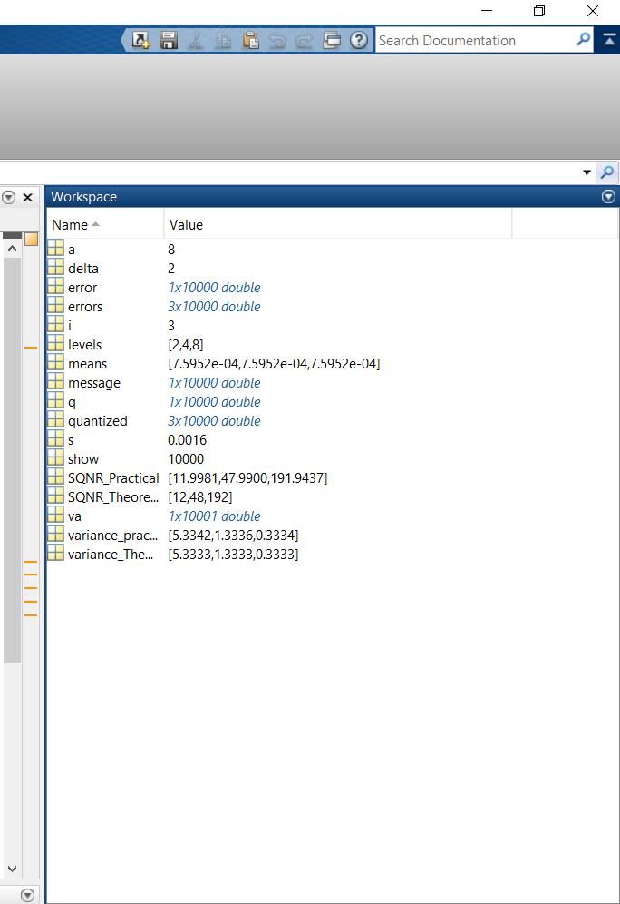

RUNNING USING PUBLISH

FIGURES OF MEAN - VARIANCE - SQNR

WORKSPACE